## Chapter 1

Chapter Review Questions

1. Explain the difference among the terms feature, feature class, and feature dataset.

2. Imagine you are looking at a geodatabase that contains 50 states, 500 cities, and 100 rivers. How many feature classes are there? How many features? How many attribute tables? How many total records in all the attribute tables?

3. If the following data were stored as rasters, which ones would be discrete and which would be continuous: rainfall, soil type, voting districts, temperature, slope, and vegetation type?

4. John and Mary are collecting GPS data together. John’s GPS says their location is at (631058, 4885805). Mary’s GPS says their location is at (1204817, 663391). Explain what is going on. What must be done to make the GPS units agree?

5. Would raster or vector be a better format for storing land ownership parcels? Give at least three reasons for your choice.

6. You measure a football field (100 yards long) on a large-scale map and find that it is 0.5 inch long. What is the scale of the map?

7. Scott is walking the boundary of a wetland area to map it. His expensive GPS records locations to the nearest 0.10 meter. Is the boundary he creates accurate? Is it precise? Explain your reasoning.

8. Imagine a feature class of agricultural fields with attributes for the crop and the organic matter content of the soil. What issues might impact the thematic accuracy of each attribute?

9. Explain some ways that GIS services are different from data that reside on your hard drive.

10. Construct an appropriate citation for the data that come with this book.

### Answers to Review Questions 1

1. A feature is a single spatial object and could be a point, line, or polygon. A feature class is a collection of similar features with the same attribute fields. A feature data set is a collection of feature classes that share a common theme and coordinate system.
2. There are 3 feature classes, 650 features, 3 attribute tables, and 650 records in the database.
3. Rainfall, temperature, and slope are continuous data types. Voting districts, soil types, and vegetation types are all discrete data types for categorical data.
4. The two GPS units are set to record location in different coordinate systems. To get matching locations, one would need to set his/her unit to record in the same coordinate system as the other.
5. Vector would be a better choice. Vector can store features with greater precision, important when storing property boundaries. Vector can store multiple attributes for each parcel. Vector can store the parcel data more efficiently with less storage space for the same resolution in raster.
6. The length of field in inches is 100 yd × 36 in./yd = 3600 in. Set up the ratio 0.5 in./3600 in. = 1/*x*, yielding *x* = 7200. The scale is thus 1:7200.
7. The boundary is being located by the GPS with a relatively high precision, so I would consider it precise. However, interpreting the location of the boundary is subjective, and the boundary itself may move over time depending on climate and precipitation, so the accuracy is not that high.
8. The crop field can be well defined for a single moment in time as it is very clear what is growing. However, the crop type could change from year to year. The organic matter value of the soil probably changes from place to place within the field, and may also vary from year to year, and so can only be considered a representative value. Knowing how it was determined might be important.
9. GIS servers can only be accessed over the Internet, so a connection must be available. Many GIS servers provide only the data requested rather than the entire data file. GIS services can be used by many kinds of devices, not just a Windows computer. GIS servers have more sophisticated security measures than local data.
10. Mastering ArcGIS ,Tutorial Data 7th edition (2015) [DVD-ROM]. McGraw-Hill Higher Ed: Dubuque, Iowa.

### Answers to Tutorial Questions 1

1. The county name is Wallowa.
2. There are 36 rows in the table.
3. The smallest county is named Wheeler.
4. The name of the MapTips field is NAME.
5. The NOAA National Weather Service provides the information, and the USGS hosts the GIS server.

Exercise Questions 1

TIP: If you need to capture a map or screen shot to submit to your instructor, you can do so by pressing the Alt-Prnt Screen keys on your computer, or using a program such as Jing or Snagit. Then paste the capture into a Word document. For help, ask your instructor.

Use ArcMap and the mgisdata\Usa folder to answer the following questions.

1. Is there a feature dataset in the usdata geodatabase? What is it called? List the feature classes it contains. Add them to the map.

2. What is the coordinate system of the feature classes in the Transportation feature dataset? (Hint: What did the data frame coordinate system default to?)

3. How many counties are there in the United States? How many of them are in California?

4. Which is the largest lake in the United States? What is its area?

5. Which state has a county named Itawamba? (Hint: Use Find in the Table Options menu.)

6. In the states feature class, what is the minimum, maximum, and average 2010 population density (POP10_SQMI) of the states?

7. Use ArcGIS Help to find a discussion of feature class basics and read it to expand your knowledge. Although this text presents three basic types of feature classes (point, line, polygon), several others can be stored in a geodatabase. List the other four types.

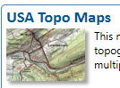 8. Create a layout page with two data frames. The upper frame contains only Oregon counties in light yellow with light green parks. The lower frame shows the lower 48 United States in beige with blue lakes. Capture the layout.

9. Use the USA Topo Maps map service in ArcGIS Online to view your university campus. Capture the map.

10. Add the country and latlong shapefiles from the World folder to a new, blank map. Display them using the World Robinson projection. Capture the map.

### Answers to Exercises 1

1. The feature data set is called Transportation. It has two feature classes, majroads and interstates.

**Method:** Use the Add Data button to look at the usdata geodatabase.

1. The coordinate system of interstates/majroads is North America Equidistant Conic.

**Method:** Open the layer properties in the Table of Contents and examine the Coordinate System tab.

1. There are 3141 counties in the United States, 58 of them are in California.

**Method:** Open the attribute table for counties and do a query for STATE_NAME = ‘California’

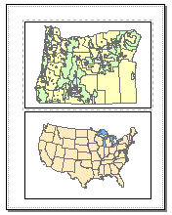

**8**

1. The largest lake is Lake Superior. It is 32,213 mi2.

**Method:** Open the attribute table for the lakes feature class and sort the Area field to find the largest lake.

1. Mississippi contains the county Itawamba.

**Method:** Open the county attribute table and use Find to locate Itawamba in the table.

1. The average 2010 state population density is 338 people/sq mi. The minimum is 1 and the maximum is 8833.

**Method:** Open the states attribute table, right-click the POP10_SQMI field and choose Statistics.

1. The other four feature class types are annotation, dimensions, multipoints, and multipatches.

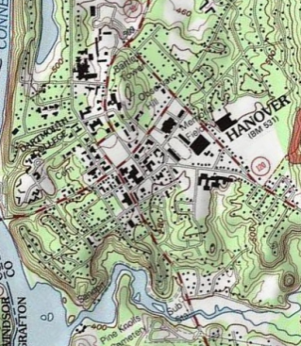

**9**

**Method:** Open Help and type “feature classes” in the Search tab. Find the feature class basics entry.

1. See map.

**Method:** Create two data frames and arrange them on the page. Activate one, add the required data, and set the symbols. Repeat for the second.

1. Answers will vary; see map for example using Dartmouth College.

**Method:** Search for ‘topo’ and add the USA Topo Maps service to the map. Zoom to the campus.

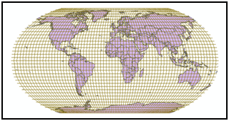

**10**

1. See map.

**Method:** Add the feature classes to a new blank map. Open the Layers data frame properties and choose the Predefined > Projected > World > Robinson coordinate system.

Challenge Problem 1: Hey, That’s Cool!

Search ArcGIS Online and find a map service that you think is interesting. Combine it with at least one data set from the mgisdata folder to create a map for a place that you know.

Capture the map in a Word document. Underneath it, construct appropriate citations for the sources of the data. Also include a statement of the coordinate system used for the map.

### Answer to Challenge Problem 1

Answers will vary.